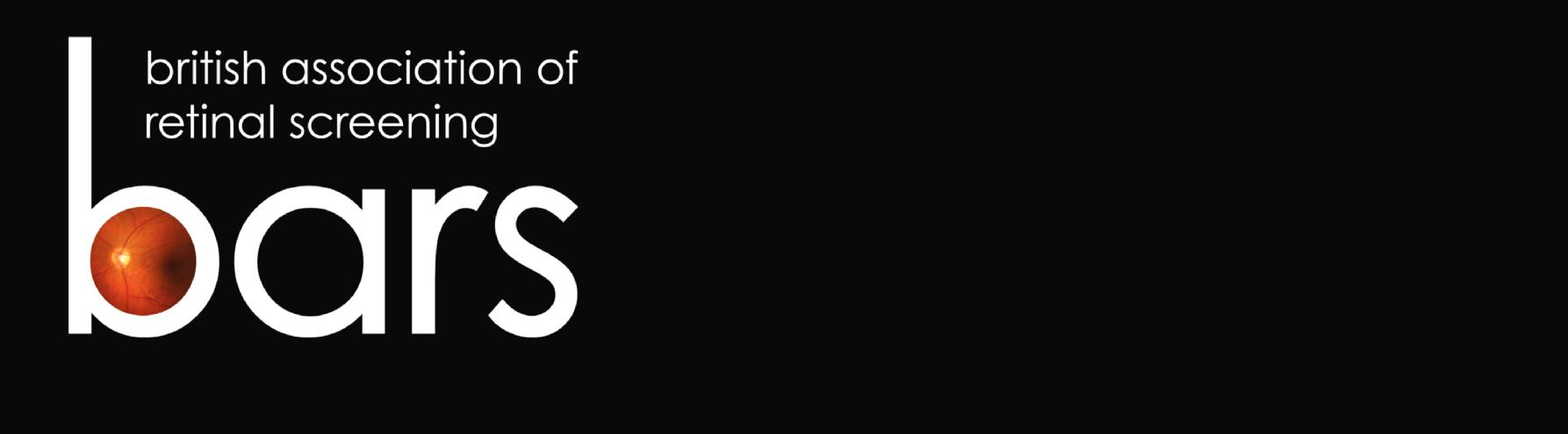
18th ANNUAL CONFERENCE

Marriott Hotel

Bristol City Centre

27-28 September 2018

www.eyescreening.org.uk

CALL FOR PAPERS, POSTERS & CASE STUDIES

If you wish to present a paper (10-15 minute presentation), poster (A0 portrait) or case study (5-7 minute presentation) at the 2018 BARS Conference, please complete this form and return it to us before the closing date. Further details can be found at the end of this form.

Closing date: 31st July 2018

Please state whether this submission is for a Paper, Poster or Case Study:

Proposed title of your Paper/Poster/Case Study:

Brief description of your Paper/Poster/Case Study:

Your full name, including title:

Your job title and organisation:

Are you a BARS member? YES / NO

Your postal address:

Your telephone number:

Your e-mail address:

Posters will be displayed for the duration of the conference and you should be available to stand by and discuss your poster with the judges during the morning coffee break on Friday 28 September. Please be advised that BARS may publish some of the conference presentations and posters on its website.

Please confirm, by signing below, that you are willing for your presentation to be published, that you have permission to share any clinical information it contains, and that your presentation or poster does not infringe on another person’s copyright.

Signed ………………………………..…………. Date ……………………

If submitting via e-mail please add your full name above and send from an e-mail address that includes that name. If printing, please sign and send to the postal address below.

Please return to: Or e-mail to:
Mrs Alison Simpson alisonsimpson2@nhs.net
BARS Administrator
Ophthalmology Department
Ward 25
Ninewells Hospital
Dundee DD1 9SY

You will be contacted shortly after the closing date with the outcome of your submission.

