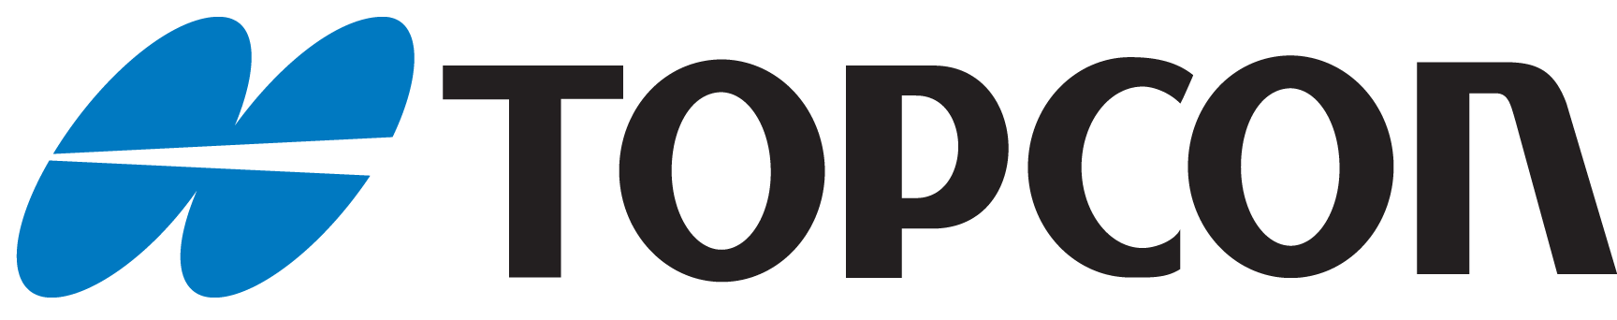

British Association of Retinal Screening
BARS/ Topcon Conference 2018
Photographic competition entry form
Name
Contact telephone number
Email address
Programme address
Clinical entry | Yes or No (how many)
Artistic entry | Yes or No (how many)
Date submitted
Has permission been gained to release the photographs | Yes or No (Entries will not be accepted without permission)

In signing the form below you are confirming that you have followed guidance and sought permission from your information governance team, for either your NHS Trust or company.
All photographs will be shown at Conference 2018, and on the BARS website and future literature for promotional purposes.
Full name (In block capitals)
Signature

Date of signature

Please note: All fields must be completed, and the form must be signed and dated for your photographs to be eligible to be entered into the competition.
Attach this form and your photo(s) to an e-mail and send to barsevents@eyescreening.org.uk by 14th September 2018
If you have any questions please contact: Richard Cragg on richard.cragg@nhs.net

