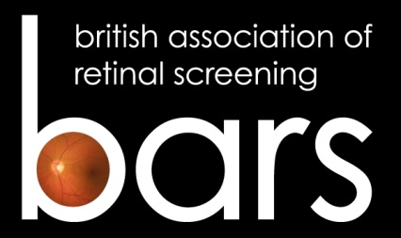

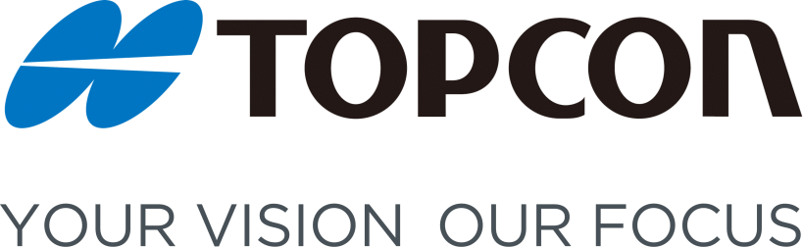
The BARS/TOPCON Photography Competition Entry Form
Name
BARS Membership Number
Email Address
Contact Telephone Number
Name of DESP
Clinical Entry/Description Attached | Yes or No (How many)
Artistic Entry | Yes or No (How many)
Date Submitted
Has permission been obtained to release the photograph(s)? | Yes or No (Entries will not be accepted without permission)

In signing the form below you are confirming that you have followed guidance and sought permission from your information governance team, for either your NHS Trust or company.
All photographs will be shown in the 2019 Conference brochure and maybe used in future literature for promotional purposes. Winners will be shown on the BARS website.
Entrant |  | Programme Manager
Name (Block capitals)
Signature

Date

Please note: All fields must be completed, signed and dated for your photographs to be entered into the competition. Please print off, complete and scan.
Attach this form and your photograph(s) to an email and send to: photos@eyescreening.org.uk by 31st July 2019

