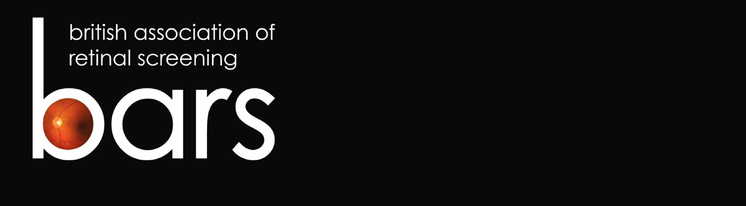
19th ANNUAL CONFERENCE

Crowne Plaza Hotel

Liverpool

26-27 September 2019

www.eyescreening.org.uk

CALL FOR PAPERS, POSTERS & CASE STUDIES

If you wish to present a paper (10-15 minute presentation), poster (A0 portrait) or case study (5-7 minute presentation) at the 2019 BARS Conference, please complete this form and return it to us via e-mail or post to the address on page 2.
Submissions must be received before the closing date of 31 July 2019.

This year we are offering a Nikon Digital SLR Camera for the best poster presented at conference plus runner-up prizes of £100 and £50, courtesy of Sense Medical Limited.
There will also be a prize of £100 on offer for the best case study presentation.

To submit your proposal, please enter the following information and
then follow the instructions at the end of this form.

Please state whether this submission is for a Paper, Poster or Case Study:

Proposed title of your Paper/Poster/Case Study:

Brief description of your Paper/Poster/Case Study:

Your full name, including title:

Your job title and organisation:

Are you a BARS member? YES / NO

Your postal address:

Your telephone number:

Your e-mail address:

Posters will be displayed for the duration of the conference and you should be available to stand by and discuss your poster with the judges during the morning coffee break on Friday 27 September. Please be advised that BARS may publish some of the conference presentations and posters on its website.

Please confirm, by signing below, that you are willing for your presentation to be published, that you have permission to share any clinical information it contains, and that your presentation or poster does not infringe on another person’s copyright.

Signed ………………………………..…………. Date ……………………

If submitting via e-mail please add your full name above and send from an e-mail address that includes that name. If printing, please sign and send to the postal address below.

Please return to: Or e-mail to:
Mrs Alison Simpson barsevents@eyescreening.org.uk
BARS Co-ordinator
Ophthalmology Department
Ward 25
Ninewells Hospital
Dundee DD1 9SY

You will be contacted shortly after the closing date with the outcome of your submission.

