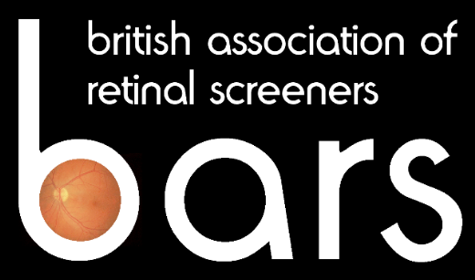 NEWSLETTER

Issue 1 Summer 2004

The BARS Newsletter is up and running!

But we need your help to make it a success

EDITOR:
I have been asked to take on the role of BARS Editor and take this opportunity of introducing myself. I have worked in an administrative capacity in the Lincolnshire Mobile Screening Service, which covers 3 PCT areas, for over 11 years. My role is currently a cross between Office Manager and Service Co-ordinator.

I have been a member of BARS since its inauguration and have found the annual conferences – I’ve attended them all - to be an invaluable source of information. The Newsletter will be an excellent contact opportunity for members to share news and views throughout the whole of the year.

Russell Martin is to take on the role of Sub-Editor and we will be working together to provide what we hope will be a useful and informative service for members.

Barbara Pickwell

SUB-EDITOR:
I am looking forward to helping Editor Barbara Pickwell, in producing a BARS newsletter. I joined the NHS in summer 2002 and took up post as Retinal Screening Technician, based at South Tyneside District Hospital, South Shields, Tyne and Wear.

Prior to joining the NHS, I worked within the publicity department of a national public transport provider, based in Newcastle upon Tyne. This involved photographic assignments, press release work and staff magazine
If you have some news you would like to share with fellow members please either submit a short article or give us a contact name to enable us to follow up the story.

production at regional and national level. I hope to use this experience to good effect.

I look forward to attending my first BARS conference this year, where I will have the chance to meet up with others involved in screening for diabetic retinopathy.

Russell Martin

CHAIRMAN:
It is wonderful to see at last the launch of this newsletter and as Barbara has already said, it will be one of the methods of sharing views and ideas on retinal screening.

Thanks to all who completed the questionnaire. This has assisted the BARS Council in getting a better idea of who is involved in screening and their particular role which is useful for a number of measures. For example, on the educational front, BARS are involved in an expert group setting up a foundation course in retinal screening which will be organised through NHS University. On the communication front, BARS have re-launched its website and judging by the number of hits is providing useful information.

I hope you find the 1st issues of our newsletter of interest and I would encourage you to send in any material that you think might be of interest to our members.

Angela Ellingford

Screening Around The World

The Chairman has contacted individuals abroad to see how they are progressing and the following are extracts from the replies she received from Western Australia, New Zealand and America.

Western Australia

In Western Australia, three separate government health agencies supervise health delivery in the one State. This is not unique to Australia and can be a deterrent to a unified screening service. Separate databases exist for the diabetic population dependant upon the delivery agency. Cultural, bureaucratic, political and remuneration complications remains a hurdle to gaining a unified approach. However, in some remote areas, biannual attendance for retinal photography is higher than city based models. Indigenous Health Workers ensure appointment attendance and follow up treatment is similarly supervised. This model has many benefits where non-compliance is considered high. Locally based, culturally sensitive, trained personnel are able to assist with all levels of information dissemination, transport and appointment attendance. Secondly, it is more appropriate that ethnic and indigenous peoples feel at ease throughout the screening and treatment process, particularly where the prevalence of diabetes can exceed 25%. The use of portable diode lasers in rural centres by visiting ophthalmologists has greatly improved attendance for treatment and is cost effective where expensive patient travel can be reduced.

Digital eye screening in a prison has been successfully tested by our group. Of note, in one prison in Western Australia, four of six inmates with hospital outpatient appointments could be diagnosed as not needing follow up appointments after telemedicine consultations.

What of the future?
Diabetic screening by non-ophthalmologists is now generally accepted as an alternative to conventional eye examinations. It can further be argued that a similar approach can be applied to other eye conditions particularly where resident ophthalmic services are unavailable. Glaucoma, amblyopia, trachoma and mobile optometric screening services can improve patient care and decrease treatable blindness rates where ophthalmic services do not currently exist. Coupled with the powerful and emerging technology of telemedicine, there are endless possibilities of moving the primary eye examination away from the office to locations where services are less than adequate all without large infrastructure costs.

Telemedicine and digital screening will play an increasing role in the delivery and assessment of screening programmes. A significant component of any screening programme is that it must be readily available to the entire target group. Mobile screening services coupled with telemedicine data transfer and high quality control levels ensuring timely treatment are prime requisites.

Annual or biannual dilated fundus examination is desirable for screening diabetic retinopathy. The importance of this schedule is widely accepted. This objective continues to elude about half the patients with diabetes mellitus. A good start has been made in organising diabetic retinopathy screening, but in order to provide a sensitive, cost effective and easily accessible screening service that achieves universal coverage more schemes must be initiated, funded and audited. Key issues in the future will be the training of the screening personnel and meeting the cost of screening. Nationwide diabetic registers will play an important role in ensuring attendance and continuing audit will ensure further improvements.

Whichever screening model, or combination of models are used, an integrated approach that is available to all of the target population is essential. A statewide, or preferably national, programme remains the ideal model. With the application of current ophthalmic technology and trained personnel, the detection and treatment of diabetic retinopathy requires centrally organised screening programmes delivering eye care in an efficient and cost effective manner.

Chris C Barry
Centre for Ophthalmology and Visual Science, University of Western Australia, Perth

USA

We still look to the UK and to Scotland for retinal screening, because with your centralized healthcare, you have the administrative skills and political will to move forward with your screening recommendations and to really put them into action. In the US, lacking those things, we must first of all create a need and then try to fill it. This process is painfully slow, but like other challenges, incremental progress will eventually get us to where we should be going.

In our program in Middle Tennessee, we currently have five camera sites established: one charity hospital, two community health centres and two Veterans Administration (VA) medical centers. Each is equipped with a Canon CR-6 camera and, variously, Canon EOS D-30, D-60 and 10D digital camera backs. Thus far, we only have fixed sites, but hope to initiate a mobile screening program soon.

Our protocol is as follows:
- Visual acuity measurement using a desktop vision tester, equipped with an ETDRS test target and optional pinhole.
- Pharmacologic dilation with 1 % tropicamide, one drop in each eye.
- Educational module, using National Eye Health Education Program educational materials.
- Imaging, using a 2-field protocol (fovea centered, optic nerve centered). Non-stereo.
- Data transmission over T-1 lines to our reading center.
- Electronic reports directly into patient charts for VA sites; others get paper reports.

Screeners are medical assistants or nurses who are employed by contracting clinics. We train them initially and provide ongoing quality assurance.

We have three graders presently: junior, supervising and a vitreo-retinal specialist. Junior reviews every case; supervising monitors most normal cases and all screen-positives; vitreo-retinal specialist reviews 20% of all cases and every one in which unusual presentation complicates reasons for referral.

Without a centralized healthcare structure in the US and lacking a strong mandate for preventive care, reimbursements for screening are generally unavailable. For the first three years of my tenure here, I learned too well all the reasons why screening for retinopathy shouldn’t work. Finally, I changed my thinking and decided to figure out how to make this approach viable in this country.

I decided that Federal reimbursement would be an essential first step. Not only would Federal money help support indigent care, but would also pave the way for private insurance companies to follow suit. Thus, I sent a letter to our local Congressman, outlining our program and hopes for the future. Luckily, this gentleman in past years was a Trustee of the American Academy of Ophthalmology. He immediately understood what I was talking about and, within a few short weeks, drafted a bill that was submitted to Congress last November.

Of course, lots of legislation is introduced to Congress, but not all is passed. I have undertaken a nearly full-time mission of advocacy for this, and am glad to say that the American Diabetes Association has just come out with a strong statement of support and endorsement for the Diabetic Retinopathy Prevention Act of 2003 (HR 3458).

As far as numbers go, looking at all our data in aggregate, we find that about 60% are within normal limits; 30% require non-urgent referrals to ophthalmology; and 10% are urgently referred.

We now have a website: www.retinopathyscreening.org that tells a bit more about what we’re up to.

Lawrence M Merlin

Vanderbilt Ophthalmic Imaging Centre, Nashville

New Zealand

With regards the screening programme here in New Zealand, it suffers perhaps by a lack of a national register of people with diabetes. Each District Health Board (21 over the country) have their own system. GPs do an annual free review of each diabetic and it is from this that reminder of retinal screening can be made. The referral is made to the local hospital where photos are taken using a variety of cameras, some mydriatic and some not. The reading of the photos is done in some areas by the Ophthalmologist, in some areas by Optometrists and in my case by a GP. I am contracted to work at Nelson Hospital one session per week. If the patient has seen an Ophthalmologist either privately or publicly then the screening can be deferred. The usual screening interval is 24 months or less if any significant retinopathy is detected. If there is advancing significant retinopathy then the patient is called into Eye Clinic for assessment.

Shaun McKenzie

Nelson, New Zealand

British Retinal Screening Vans

Mobile units have been exceptionally suitable for rural areas, rather than static cameras. We take a look at the different designs of vans recently purchased by two long-running retinal screening services.

Lincolnshire

Lincolnshire’s Mobile Service – up and running for nearly 12 years thanks initially to a charitable donation by Radio Lincolnshire – has finally been able to replace its original ageing van with two new purpose-built mobile units. Senior Photographer, David Hyde, gives us his account of their purchase.

We started the tendering process late summer of 2003 and, from the quotations received, decided to “take our business” to Fame Commercials of Colchester. This firm, who I found on the Internet, go a step past simply converting van based vehicles. The service they provide is to supply a chassis/cab unit (usually FIAT or Citroen) and then replace the original chassis with their own, custom built and much larger, unit. On to this they then build, using GRP panels, what is effectively a mobile office, to your own specification and design. They can supply basically anything you want, the only limitation being your own finances!

We chose to have two 5 metre bodied vehicles, designed with a patient waiting area towards the front, and the screening area with camera to the rear. Whereas our old vehicle had no wheelchair access, the new units boast this facility, using a strong but lightweight fold out ramp, which can be deployed as needed. The patient can then be wheeled directly up to the camera for screening. The vehicles also have three independent heating sources, an air-conditioning unit (at last!) and ample storage for consumables. Also we now have an internal headroom of 7 feet – so no longer have to mind our heads!

At the same time as obtaining the new vehicles, we have also purchased two new digital cameras. We have remained loyal to Topcon, this time choosing the TRC-NW6S model. We are running this directly into Asus laptops, as the acquisition software now resides in the camera, not in the computer as was previously the case. Being able to use laptops means that our system is now far more rugged than before but does not lose out on usability as we also have 250Gb external hard drives, and 19” Philips flatscreen monitors. We have designed the system with a view to, hopefully in the not too distant future, moving to Real Time Grading.

Externally the new vans are exceptionally striking in their design. We found that the old van, especially as it deteriorated over time, did not make the desired impression when parked at surgeries. Frankly it looked like an old builder’s van and patients sometimes did not even see it because of this, subsequently missing their appointments. The new units are much bigger (external dimensions are 24 feet long, by 7 feet wide, by 10 feet high). This helps to make them more noticeable, but we decided to make them even more striking by specifying that they be supplied in yellow! Initially a lot of people thought this sounded dreadful, but, almost without exception, once viewed “in the flesh” they have been very well received and admired. To top it off, each van has a blue wind-out awning to protect the entrance from the elements, and we have a “logo”, with the words “Lincolnshire Diabetic Retinopathy Screening Service”.

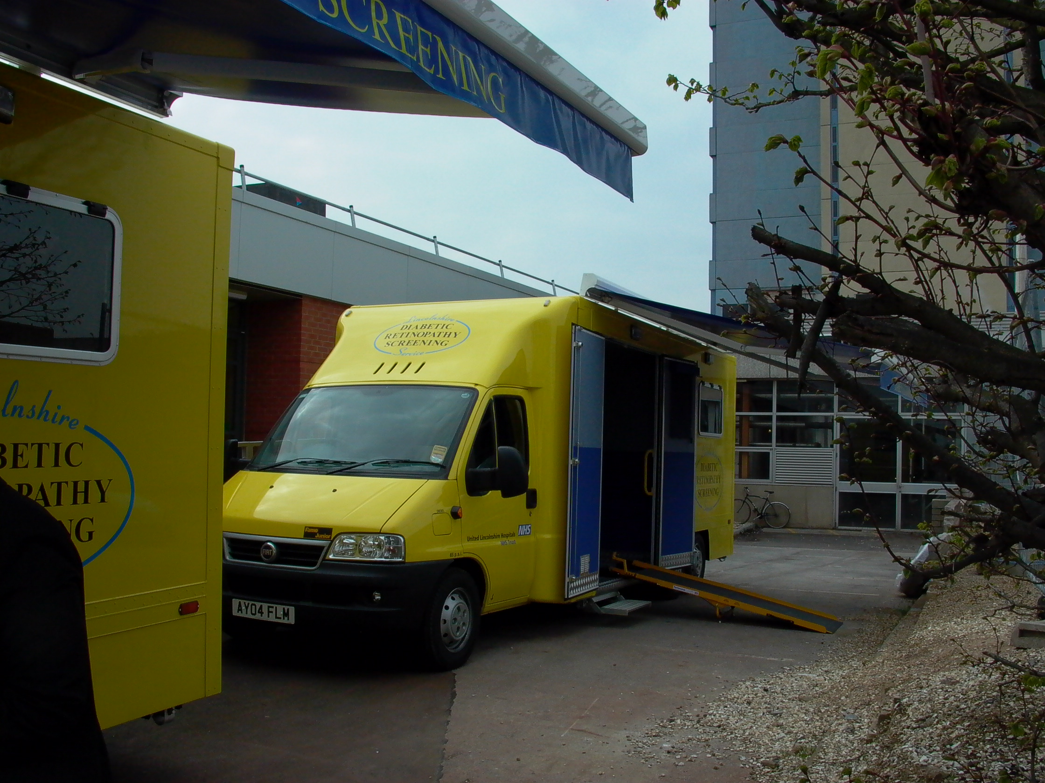

If anyone wants to know more about the vans please feel free to contact David Hyde screening@davidhyde.co.uk

Norfolk

The Norwich screening service was one of the first up and running mobile services in the UK. Maggie Flatman, Eye Screening Manager in Norwich, gives us her account of the purchase of their vans, including their latest vehicle.

Van 1: The first Norwich eye screening van, an ex Bedford ambulance, became operational in 1990. We visited GP practices and screened the patients in the van. This housed a fixed Canon CR4-45NM fundus camera, bench seats and a Snellen 3m chart. However, the van was not quite long enough for the patients to stand inside to read the chart so they had to stand on the step outside for the required distance. If it was raining, ‘Mary Poppins’ appeared!

Van 2: In 1995 a group of local fundraisers gave us sufficient money to purchase a second-hand Renault Master LWB van which at the time was painted bright red and used as a tool van. This was converted in a similar style to the first van and the Canon camera and table transferred. Screening as before was undertaken in the van. In this van the patients could stand inside to read the VA chart!

Van 3: In 2000 we went “digital” with a Canon CR6-45NM camera and a brand new Mercedes Benz Sprinter van, again with screening taking place inside the van. We were able to introduce many improvements from our experience of the previous 2 vans, i.e. Air-conditioning system/heating system; Folding rear steps; a warm, non-hospital colour on the walls – pink carpet together with mottled pink floor; plenty of storage space, plugs, telephone and lights/spotlights.

Van 4: In 2002/3 our screening interval was creeping up to an unacceptable 24 months and van number 4 became a reality.

We were previously unable to screen patients with mobility problems/wheelchairs because of the steps on the vans and these patients were screened at the hospital. Therefore, we approached our GPs requesting a room for screening on their premises, which would have resulted in purchasing a smaller van and wheeling the camera into the surgery. However, we did not get full agreement to this and rather than returning to the previous fixed camera screening, we sought a dual purpose solution. The company who carried out the previous conversion (Commercial Bodies East Anglia) came up trumps and produced a layout and plan so that the van could be used either with a fixed camera or the camera wheeled into the surgery.

The rear doors are used only for moving the camera in and out of the van. The camera is wheeled onto the Ratcliff tail lift and lowered to the ground by remote control. The camera locks onto the tail lift, which will transport the screener also if required. The side door is used for patient entry when screening in van and has an automatic retractable step which has a manual override. This comes out when the door is opened and goes in when the door closes. The table holding the camera is a standard Canon motorised table converted by the fitters with an anti-vibration camera frame.

It was unanimously decided to have a pink interior again and it is fitted out with L-shaped padded seating with lift-off seats disguising storage underneath. Further storage is provided in 2 slimline cupboards with sliding doors.

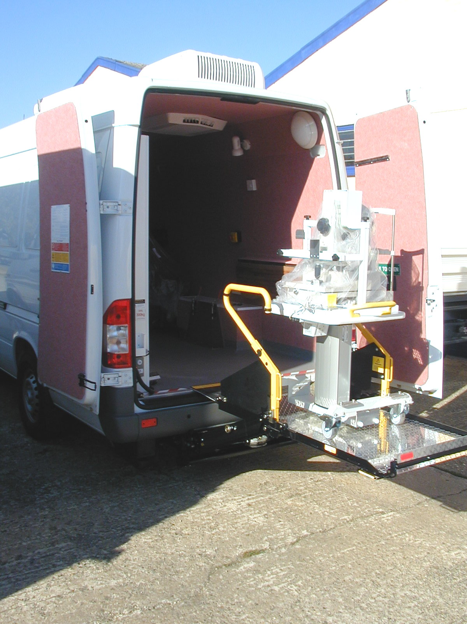
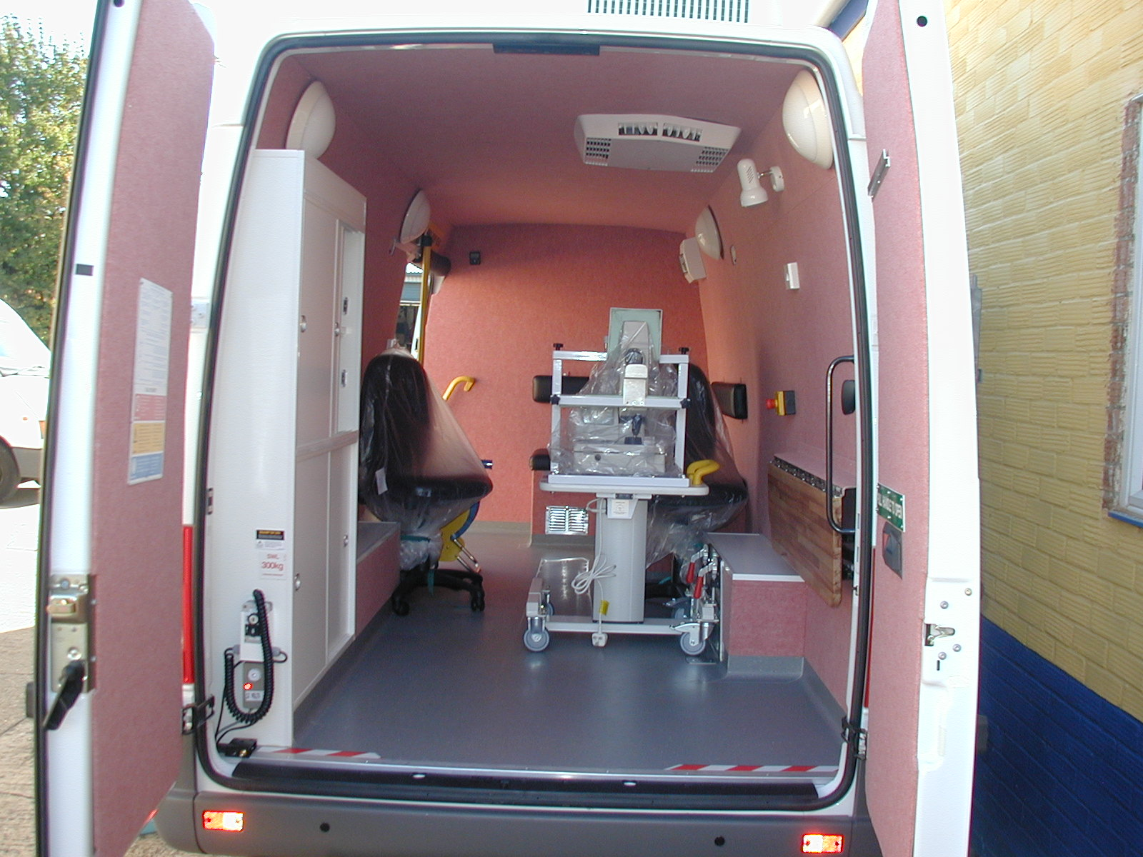

Maggie Flatman would be pleased to hear from anyone who would like to know more about the new van.
Margaret.flatman@nnuh.nhs.uk

We would like to feature more aspects of existing services in future issues of the Newsletter. Please send us information regarding your screening service.

The Numbers are Rising

An international team of researchers say diabetes rates will double worldwide by 2030 even if the obesity rate remains stable. The rate will go up even higher if, as expected, more people eat a so-called Western diet and stop exercising.
The researchers from Britain, Australia, Denmark and Switzerland used United Nations data to project future diabetes rates and say numbers will rise from 171 million in 2000 to 366 million in 2030.

BARS Annual Conference 2004

The planning has been underway for some time for this year’s Conference, which is to be held 23-24 September in Dundee. The provisional programme is already shaping up for an excellent event and can be viewed on the BARS website http://www.eyescreening.org.uk . The Event Organiser, Angela Ellingford, said “If you want to know about QA, retinal screening qualification and regulation it would be in your best interest to come along to the annual conference. So we will see you then!“

Bursaries

BARS Council is pleased to announce that the following have been awarded bursaries to attend this year’s conference:

Marion Lyon
Gurmesh Lohia
Nicky Hadley

Topics to be covered in forthcoming issues of BARS Newsletter to be made available to BARS members:

Conference highlights
Training and regulation issues
Examples of good practice in existing services

If you have an item of interest or comments you would like to share with fellow members, write to the BARS Editor via the BARS Website http://www.eyescreening.org.uk.

