 NEWSLETTER

Issue 7 September 2007

Conference 2007

BARS 2007 Conference is being held at the end of this month (27th – 28th September) in Bristol. The draft programme has been available to view on BARS website during its development into what promises to be an information-packed event for new and experienced screeners alike. There will be a series of presentations with particular emphasis on the City and Guilds Certificate in Diabetic Retinopathy Screening. Question and Answer sessions are also planned to give the opportunity for debate. The number of delegates attending BARS Conference has risen year-on-year, reflecting the high priority placed on the detection of retinopathy and the rapid escalation in the number of NHS staff employed in retinal screening programmes.

EASDec 2007



The EASDec meeting this year was held in Rome from 25th-27th May at the Pontificia Urbaniana University and was organised by Francesco Bandello an Ophthalmologist from Udine.

It is primarily a meeting for Ophthalmologists and Diabetologists but I have found it really interesting over the last 9 years and it was good to be joined by fellow screeners this year! The venue was lovely and the Italians entertained us so well. The welcome reception was held in the Capitoline Museum and we had a private guided tour of the museum followed by a buffet dinner on the roof terrace overlooking the Foro Romano and the rooftops of Rome.

The gala dinner the next night was held at the equally beautiful Villa Monte Mario preceded by prosecco and canapés in its lovely grounds.

The meeting covered the role of angiotensin blockers in treatment of retinopathy, pathophysiology, a section on epidemiology and screening. A paper on proliferative retinopathy as a predictor of mortality showed the presence of albuminuria as the most significant risk factor for the patient. (Jakob Grausland) Another showed that the presence of cotton wool spots quadrupled the chances of the patient having a heart attack or coronary artery disease (Massimo Porta). There was discussion as to whether diabetes is an inflammatory disease as leukocytes are present in the retinal vessels within a week of the onset of diabetes. These block the capillaries temporarily and then disappear but they damage the cells in the vessel walls in the process. (Tony Adamis)

The final paper (Edoardo Midena) reported that neuronal cells are damaged even when vascular cells aren’t and that there was altered visual function in the diabetic retina. This affects contrast sensitivity, dark adaptation, colour vision, visual field sensitivity, macular recovery, pattern and multifocal ERGs and oscillatory potentials. The dendrites change and widen, there is blue cone loss and the rods decrease in length.

The next meeting will be held in Amsterdam from 30th May-1st June 2008 (see www.easdec.org)
For full abstracts see www.eur-j-ophthalmol.com.

Jacqueline Mansell

Laser Anxiety

A paper has been published in Italy “Perception of, and anxiety levels induced by, laser treatment in patients with sight-threatening diabetic retinopathy. A multicentre study” Trento et al. The study comprised questionnaires issued to people with diabetes in 4 centres; approximately half awaiting laser treatment and half (the control group) awaiting non-interventional visits.

In general, anxiety levels were understandably higher in people awaiting laser. Anxiety was highest in females and in less well educated patients. Comparison of the Centres revealed that anxiety was highest in the centre which did not provide dedicated time for information and pre-intervention counselling. Surprising though it seems, previous experience of laser treatment did not modify anxiety. According to this study, the only factor to reduce anxiety was time set aside for information, education and reassurance.

Diabetes UK Scotland/RNIB Scotland
Retinopathy Screening Awareness Campaign 2007

A Diabetic Retinopathy Awareness campaign has been organized in Scotland its aim is to raise awareness among people with diabetes in Scotland of the importance and availability of retinopathy screening and to promote take-up of the service. There is a particular focus on tackling DNA rates

The campaign is the fulfilment of the Scottish Diabetes Action Plan commitment to ‘produce a strategy to promote the importance of eye screening which will be implemented during 2006/07’ (Diabetes Action Plan 2.1)

Background
Diabetes UK Scotland and RNIB Scotland, who are jointly leading the campaign, have been in discussions with the Scottish Executive, the Scottish Diabetes Group and the Diabetes Retinal Screening Collaborative. The campaign is being funded by the Scottish Diabetes Group with significant staff resource being contributed by Diabetes UK Scotland and the RNIB Scotland.

An independent researcher was briefed to write a report on retinopathy screening and related issues.

Following a tendering process, Irwin Stuart, a Glasgow-based design agency was commissioned to develop the campaign messages and visuals. Materials include: posters, fliers, post-its and a short DVD. Irwin Stuart undertook focus group work with people with diabetes to sharpen the messages and materials.

Approach – report/launch/roll-out
The campaign was launched during Diabetes Week 2007 (11 – 16 June). The venue which was in Glasgow, demonstrated mobile screening vans and a fixed camera setting. Nicola Sturgeon the new Minister for Health was invited to formally launch the campaign. Key stakeholders, including screening service providers, people with diabetes/visual impairment were also involved.

An agreed schedule of roadshow stops (from June through to November 2007) has been arranged. These provide the backbone of the campaign, i.e. a series of local launches and activities to raise awareness of the (local) screening service and the importance of retinopathy screening. Campaign organisers are liaising with the screening service manage clinical networks (MCNs) over the next few months to come up with a roadshow schedule which is helpful to local providers. Local launches will involve screening providers, optometrists, pharmacists, MCN members, voluntary groups, MSPs, local celebrities and will target local press and broadcast media to maximise coverage.

Roadshow campaign packs will be developed over the next few months in order to provide local stakeholders – coordinators, administrators, MCN managers, voluntary groups, etc – with the materials to maximise the benefits of the campaign locally.

Angela Ellingford

Mobile Diabetic Retinopathy Screening Clinics

NHS Tayside operates two Mobile Screening Clinics, which travel to Health Centres and Hospitals throughout the area conducting Screening Clinics. The Mobile Clinics are operated by members of the Screening Team on a rotational basis. As the Screening Team is a mix of male and female personnel with a range of physical abilities, the design of a system that caters for all whilst enabling screening activities was challenging. Also, facilities are required to allow the Screener to control breakdowns and thus limit Patient appointment cancellations.

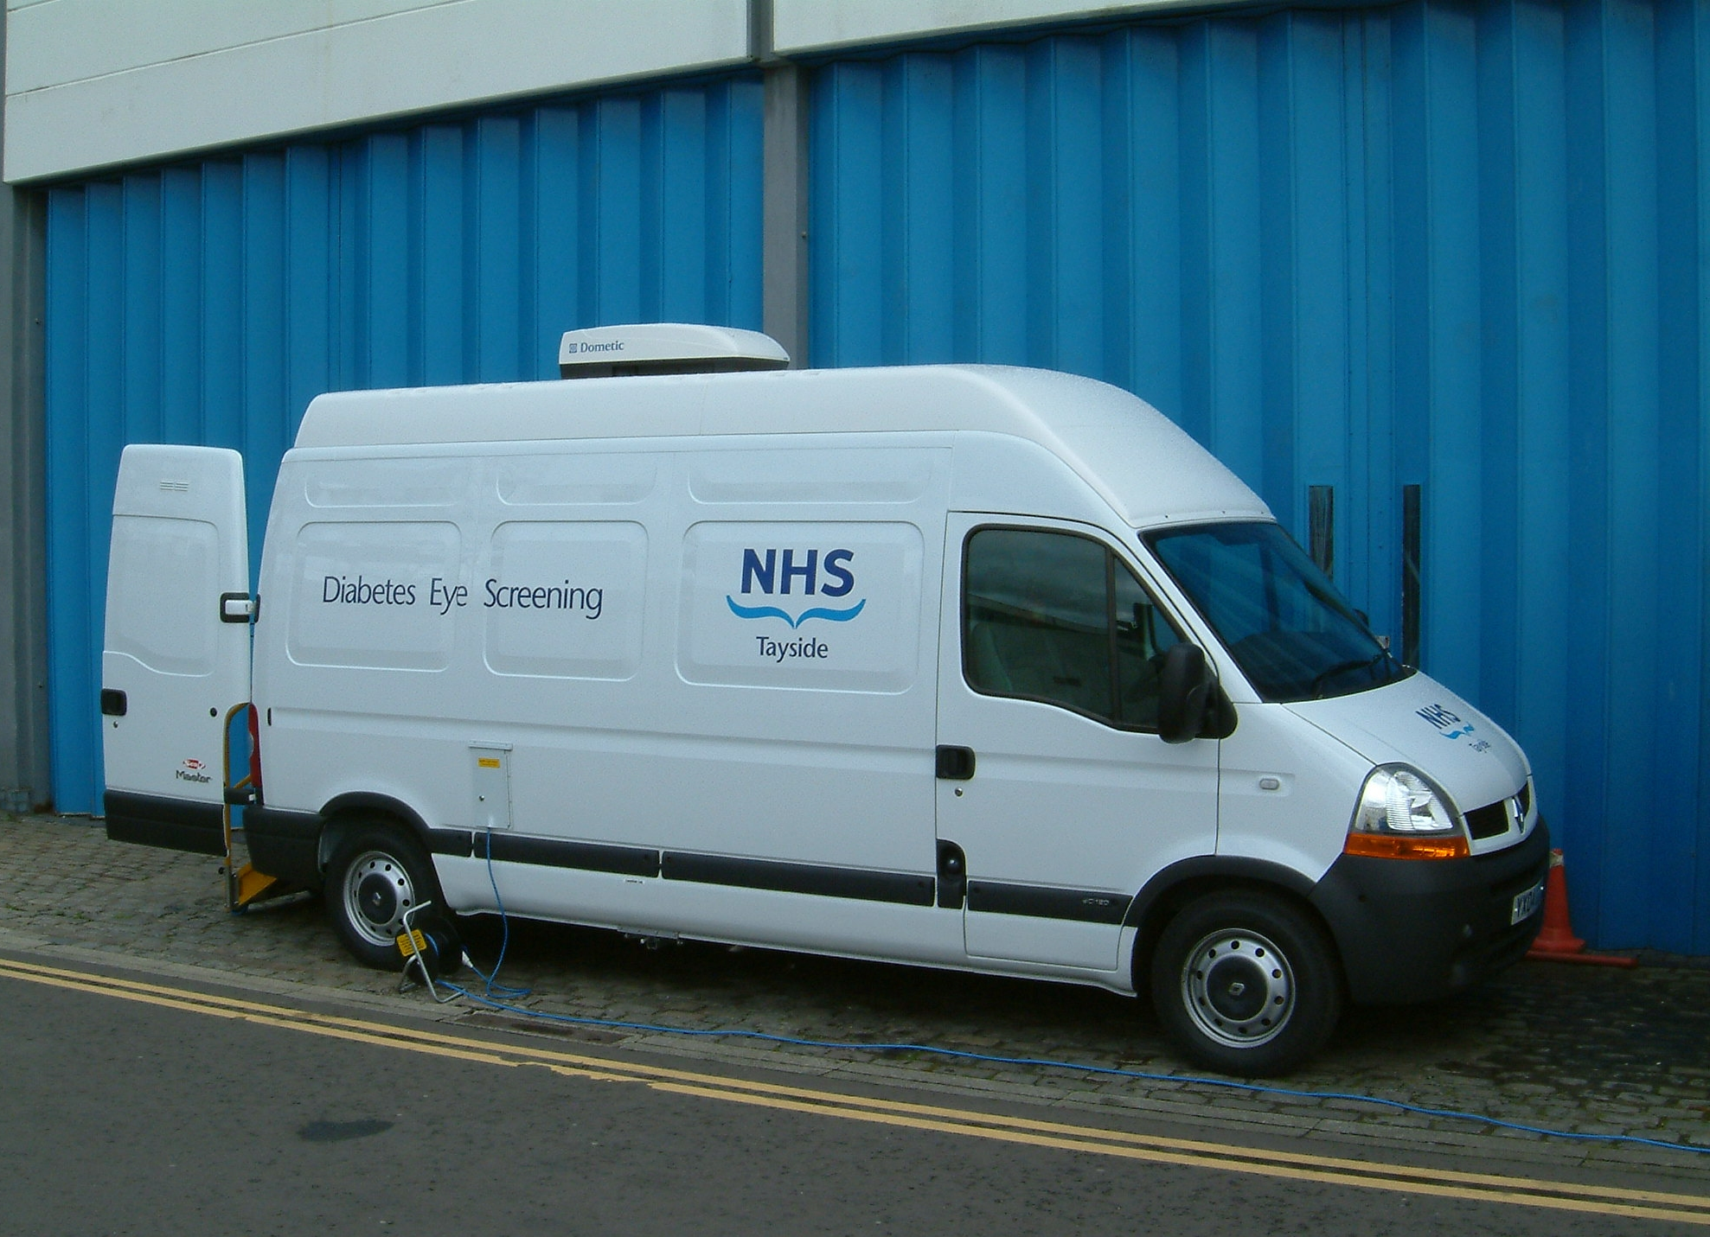

Mobile Clinics (EyeVans)
A single Mobile Clinic was used between 1989 and 2004 when a second Unit was purchased. The original Mobile Clinic was replaced in 2005. Both current Mobile Clinics are contained within Renault Master 2.5 litre vans. Experience gained with the original unit was applied to the design of the current Mobile Clinics.

The cargo area is split into two, a large clinic area in the forward section for conducting screening and a rear waiting area able to seat at least two waiting patients. Each area is self-contained and separated by doors which provide a degree of confidentiality in the screening area. When screening the external rear doors are kept open to provide some shelter for the steps and internal weatherproofed sliding doors keep the weather at bay. The floor is also weatherproofed and slopes outwards to allow rainwater to drain away. The internal environment is climate controlled (thermostatically heated and cooled) with a portable fan heater for use when more heat is required.
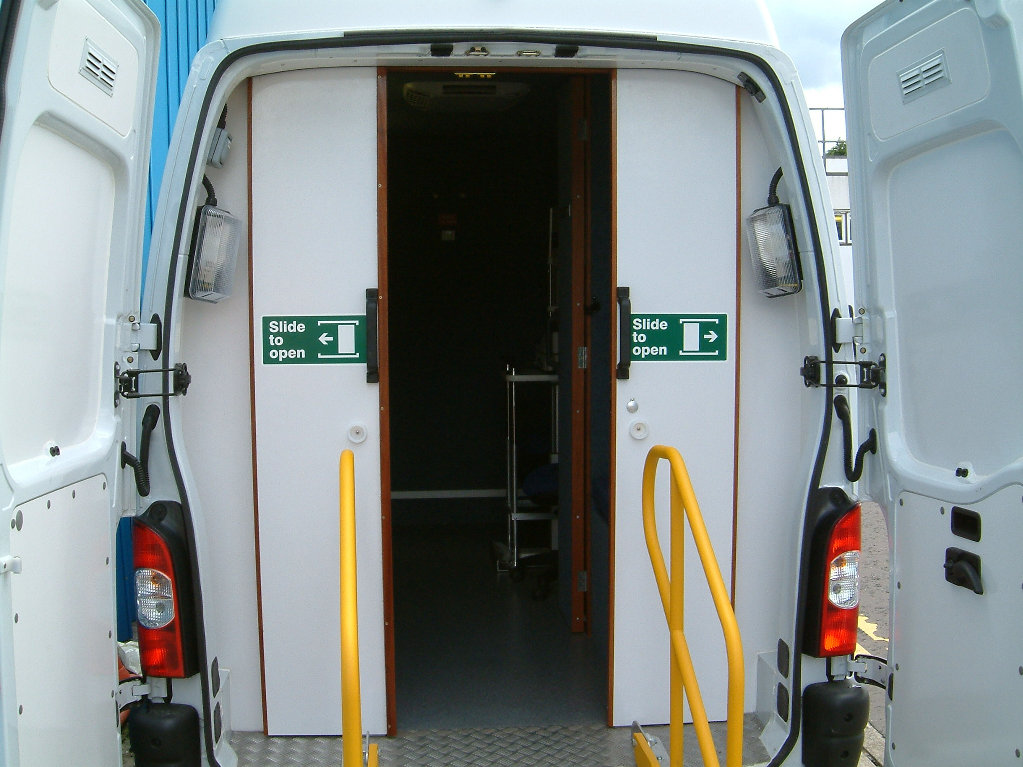

The walls and roof are insulated and covered in carpet material to stop condensation. A fixed programmable heating system ensures the camera is kept at working temperature during transit and ready for use on arrival at the screening site. Patient access steps into the clinic were designed in accordance with the ‘Public Accessibility Regulations’ and the ‘Disability Discriminations Act’. They are wheeled to allow flexing of the vehicle as Patients mount the steps and hinged at the inboard end for ease of handling and storage.

Single Role/Multi Role Mobile Clinics

Mobile Clinics travel to Health Centres and are suitable for Patients that can mount the steps. Patients who are assessed by their GP as unable to enter the Mobile Clinics are screened at a static site, usually within an Outpatient clinic environment. Also, static sites allow more appointments to be made because there is no set-up or pack up periods required, apart from the first and last day. To accommodate this mix of screening clinics, one of the Mobile Clinics has a multi use role. It can be used as a Mobile Clinic or can transport up to two sets of screening equipment and Screeners to any site and then be used to carry personnel to and from Ninewells during the screening period. Medical Physics undertook design and construction of the static site equipment. The other Unit is a single role Mobile Clinic.

Manual Handling

Risk assessments reveal two areas of concern; infirm Patients and moving equipment.
Patients: all Patients attending Screening are assessed by their GP before an appointment is made. If assessed as unable to enter a Mobile Clinic then they are appointed to a Static Screening Clinic. Patients arriving at a Mobile Clinic who are clearly unsuitable have the situation explained to them by the Screener and given a Static Clinic appointment. Patients in wheelchairs are screened at Static Clinics using a Medical Physics designed camera table which allows the wheelchair to fit underneath. Any Patient who cannot be screened at a static site is given an appointment for Slit Lamp screening in an Ophthalmology department. These precautions ensure no Screener is put in the unsafe position of manhandling Patients.

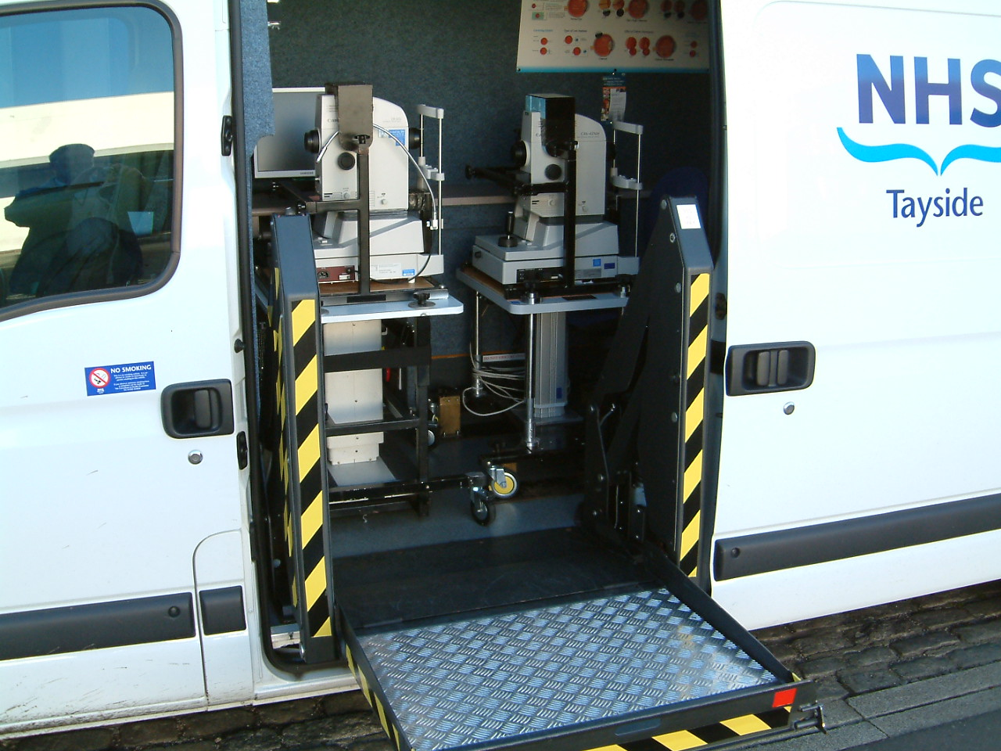
Transporting 2 cameras
Equipment: Each Mobile Clinic carries a folding mini-trolley for moving computer and other small equipment. The cameras are mounted on wheeled tables for ease of movement; these tables also have a securing cage to prevent movement of the camera during transportation. The multi-role Clinic has a powered side lift for moving equipment in and out of the clinic area; full operating protocols for the side lift are held in the Unit.
Screeners complete annual Manual Handling training and are given periodical on-site training in the use of the side lift.
Changing wheels when punctured: This is performed on request by the RAC or the nominated Servicing Agent (AM Phillips).

Clinic Programme and Appointments
The Mobile Clinic programme is displayed on the Tayside Diabetes Clinical Network site (www.diabetes-healthnet.ac.uk). Patient appointments are at ten-minute intervals with double appointments given to those who require more time. Patients who miss their appointments at their own Health Centres are encouraged to attend screening at any location shown in the programme without an appointment. Instructions are on the web page. They should attend between 11:00 and 12:00 or 13:00 and 14:00. Health Centres are warned to send no more than one Patient per day by this method to avoid overloading the Screener.

Screener Working Hours
Because of the large area covered, travel takes up a large part of the working day; and can reduce the number of appointments available. After experimentation, it was found more efficient to work four long days and one half day per week. Each long day begins and ends in Ninewells 08:30 to 17:20 with breaks at 10:40 to 11:00. 12:30 to 13:00 and 14:40 to 15:00. The remaining half-day is spent in Ninewells. The vans are cleaned inside and out, checked over, any minor repairs completed and restocked ready for the next four-day period. Images and information recorded during the preceding four days is transferred to the main screening system.

Travel and equipment setup/packup timings
A database of time required to transit to a screening site is used for appointment planning. Timings are based on previous journeys and checked against the AA Route Planner; they are updated as road conditions change. Ten minutes is added to the journey time to allow for any hold-ups.
Equipment in the Mobile Clinics is strapped in its operational position for travel, thus requiring minimal time to setup on arrival and packup before departure. Thirty minutes is allowed for each setup and packup period. The Screener also cleans the clinic area before departure from the screening site.

Servicing, repair and fuel
The Senior Screener maintains a servicing diary for vans and equipment. Maintenance periods are allocated in the programme. Each Mobile Clinic carries instructions and details of who to contact in the event of breakdown or equipment failure. A charge card is provided for refuelling at any BP, Shell or major forecourt operator station. Receipts are forwarded to Operational Services weekly.

Driver Training
It is a requirement that Screeners hold a full driving licence with no endorsements. Each Screener completes the two day Safer Driving Course with the Ambulance Service and is offered follow-up training if required. In house Driver Training is conducted on an opportunity basis.

Electrical Safety
Safety is of paramount importance to the Screening Programme. To ensure electrical safety:
Power to the Mobile Clinics is protected by Residual Current Detectors.
All equipment is Electrically Safety Tested annually by Medical Physics.
Daily Pre-use Safety Checks are conducted by the Screener and results recorded. The Senior Screener retains the completed record forms for at least two years.

Vehicle Checks
The Screener conducts three sets of vehicle checks:
Pre-Journey Safety Checks (as per NHS Tayside Policy)
Daily cockpit checks (as per Ambulance Service Safer Driving)
The Screener also completes weekly Vehicle Checks and records the results on the Driver Vehicle Check and Defect report form. The Senior Screener retains the completed forms for at least two years.

Parking at Health Centres

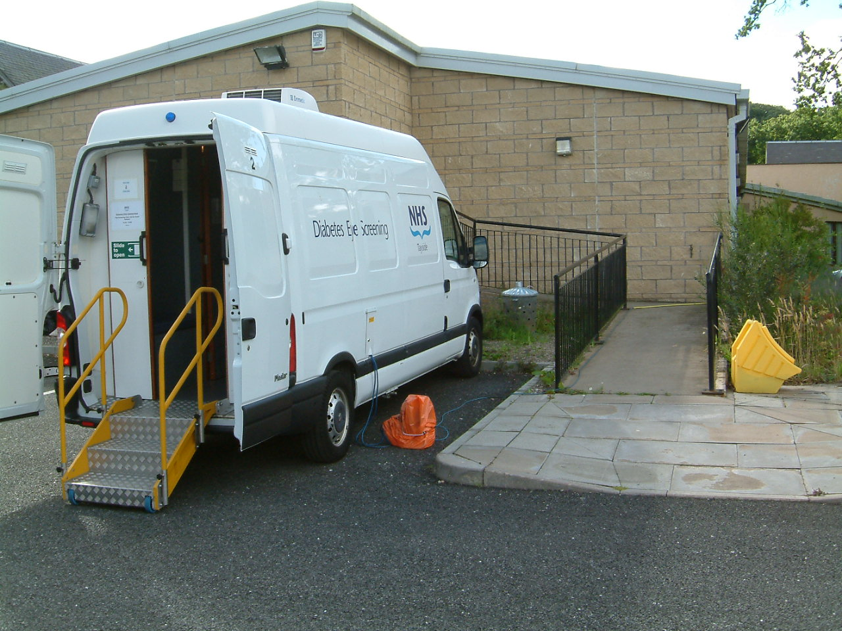

Parking a large vehicle in a busy Health Centre car park can cause problems, not least of which is that Screening appointments could be delayed or cancelled because the Screener cannot find a suitable or safe area to park. To alleviate this problem, a protocol has been developed; ‘Safety of Mobile Clinic at GP Health Centre’. The protocol and attached checklist is sent to the Health Centre so they may prepare a safe area for the Mobile Clinic. The protocol also includes instructions for the Screener. Screeners are also encouraged to liaise with the Health Centre over parking areas before arrival.

Safety and Security when Lone Working
Full details are shown in the Diabetic Retinopathy Screening Programme protocol. Each Mobile Clinic is provided with a mobile phone with pre installed contact numbers. Screeners are instructed to switch the phone on before leaving Ninewells and off on return, and to ensure it is charged before handover to the next Screener.
Mobile Clinics are fitted with Panic Alarms. When operated by the Screener, an internal high-pitched audio alarm activates with external sirens and flashing blue lights. The alarm is de-activated with a key held by the Screener. On arrival at the Health Centre the Screener will place a notice with reception; the notice gives instructions on what actions are to be taken by the Health Centre if the alarm is activated. The notice is removed as the Screener departs thus notifying Health Centre staff of the Screeners movements. The Alarms are demonstrated to Health Centre staff as required by the Practice Manager.
A nominated Screening Programme staff member will check if the Mobile Clinic returns to Ninewells; there is a phased escalation of events if the clinic is overdue.

Richard Clark

Website

As with all projects, there have been a few setbacks but the hard work will soon result in the replacement of our out-dated, clunky website with a new user-friendly site. One of the delays, we are happy to report, was the fact that Grant Duncan, who is master-minding the transition, had the joyful addition of a new baby to his family earlier this year! Our Congratulations to Grant!

Grant hopes that the website will be ready in time to display the finished article at conference. Check out BARS website regularly for news of jobs, courses and conference details, etc. www.eyescreening.org.uk

If you wish to submit an article for publication in the newsletter, please contact
the Editor / BARS Council via BARS website www.eyescreening.org.uk

