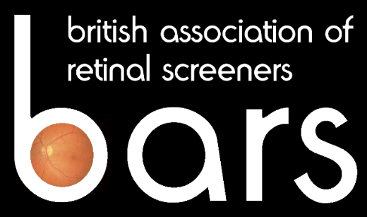 NEWSLETTER

Issue 11 October 2009

Report on the EASDec Conference Oxford 2009



The 19th EASDec Conference was organised by Peter Scanlon and his team and was held at the Natural History Museum in Oxford.

Sally Scanlon had arranged a partner’s programme which included lunch at Brasserie Blanc and a visit to the botanical gardens. It was a very well organised and extremely enjoyable event.

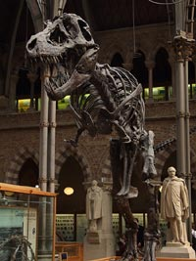
The first session covered pathophysiology and research and was followed by the keynote lecture 'Microvascular Outcomes in Recent Trials' by David Matthews from Oxford. Trials have shown that it takes 9 years to see differences in the development of complications between patients with tight and poor glycaemic control, but that the difference between those with good and poor blood pressure control is evident by 4.5 years and significant at 7.5. There does not appear to be a legacy from having poor blood pressure control in the past, once blood pressure is normalised. However, there is a legacy (a continuation in the development of retinopathy) in those with, initially, poor glycaemic control after it normalises.

Session 2 was on epidemiology and screening. In Portugal, a 10 year follow-up of patients showed that the turnover of microaneurysms is an indicator of progression to CSMO. An increase of 2 microaneurysms/ year is significant.

In Denmark, pregnancy does not seem to be a risk factor in the development or worsening of retinopathy. This may be due to better control but there is a general improvement across Europe.

A presentation followed on ‘Diabetes and Asymptomatic Retinal Emboli’ (and their implications). Most were cholesterol emboli and carotid Doppler scan showed only mild stenosis. Only 8 needed endarterectomy but by 4 years from identification of the emboli 25% had died. Transcranial Doppler was suggested as a better investigation in order to prevent strokes and death but this is costly
and few departments have access to them.

Sunday saw a fascinating talk on the Leopard Programme, a retinal screening programme in Ethiopia which has been running for 18 months. Half the population is under 20 but is now living long enough to develop retinopathy. The screening is run on the British model but power supplies are very unreliable. They have 1 medical retinal specialist for 77 million people (and we moan!) 12% ungradable images, 61% retinopathy incidence and 28% maculopathy. At present the referral rate is 51% with 7%

severely sight-impaired and 12% sight- impaired. (see article later in the newsletter)

The team from Prague reported that HbA1c was a predictor of retinopathy but not of nephropathy and that people with identical blood sugars can have different HbA1c.

EASDec next year is in Paris (21-23rd May) and in Gdansk in 2011

Jacqueline Mansell

A Nice Document - Report on EURETINA Congress in Nice, May 2009

It had become an in joke that whilst my colleagues have been dispatched to conferences in the USA, India, Rome and Amsterdam, the furthest that I had managed was Bolton. Don’t get me wrong, Bolton is a lovely city and the OIA conference I attended was extremely interesting. But let’s face facts… glamorous, it ain’t. So, it was with a degree of smugness that I faced my workmates when I was invited to attend the European Society of Retina Specialists 9th annual EURETINA Congress in Nice on the French Riviera. The prospect of soaking up the spring sunshine and the glitzy atmosphere was one I relished. Anyway, what if I would be speaking as a last minute replacement for some bloke called Stephen Aldington? I wasn’t about to let that spoil my fun.

The EURETINA Congress runs over four days and includes lectures, workshops, courses, debates, poster presentations, an enormous trade show and an opening ceremony featuring a mesmerising performance by a virtuoso pianist. Delegates numbered in their thousands and the conference venue was on a massive scale comprising three large auditoria for lectures, - the largest of which could have fitted the average BARS conference at least ten times over – an aircraft-hanger sized exhibition hall and countless side rooms running an infinite number courses and workshops.

However, big is not necessarily beautiful and with a huge number of themes covered, including such diverse topics as ‘an overview of mechanisms of autoimmune uveitis’ and ‘Cyclodextrin nanoparticles for drug delivery to the retina ‘ it would take a lifetime to cover all the subjects of interest, let alone everything on offer and (let’s face it) life’s too short. With this in mind I made a plan to try to catch as much as possible of the content relevant to DRS during the two days I was there. Thursday morning opened with a free paper session on AMD and I enjoyed EURETINA’s President Jose Cunha-Vaz’s presentation on the theme of automated detection of macular changes in dry AMD using the Retmarker application and Dr D Chow of Canada’s groundbreaking paper on macular risk: the first genetic test for AMD. The remaining papers in the session described the results of a number of studies looking at drug treatments for the condition, highlighting the importance of detecting cases of AMD as part of a screening programme.

The first afternoon session I attended covered the subject of physiopathogenic mechanisms of macular oedema and, while none of the papers dealt directly with macular oedema in diabetic retinopathy, all were of interest and added something to my knowledge. The main afternoon session dealt with the theme of imaging to monitor disease progression, a topic close to my heart. This session included excellent presentations on the turnover of microaneurysms to evaluate progression of DR using automated image analysis, and the benefits of co-registration of different image types to for a better understanding of disease progression and planning treatment.

On Friday morning I participated in an instructional course on the theme of screening for diabetic retinopathy organised by Cathy Egan from Moorfields and delivered a presentation on the validation of an automated image analysis system for use in the Scottish National DRS programme. The session included presentations by Robert Johnson from Medisoft on the work being done by his company with the NSPDR to facilitate better IT links between DRS programmes and hospital ophthalmology services and an excellent piece on DRS in France and the challenges faced by Professor Pascal Massin in Paris. I also managed to catch the encouraging results of two separate studies, one in Dundee and one in Paris, looking at the effectiveness of the Optomap laser scanning ophthalmoscope in detecting diabetic retinopathy before attending the main session of the day on vascular diseases and diabetic retinopathy.

Papers in this session included a review of the importance of inflammation in the pathogenesis of diabetic retinopathy, a fascinating piece entitled ‘Beyond Thickness: Neurological Remodelling after Macular Oedema’ and two pieces on the treatment of retinal vein occlusions, including the use of ranibizumab for macular oedema secondary to vein occlusions.

Two days was my limit - both mentally and in terms of time off from family life - you can imagine that I was somewhat shell-shocked by the time I reached the Cote d’Azur airport and slumped into my economy class Easyjet seat, taking a welcome sip of my non-complementary Bloody Mary.

But what about the sunshine and glamour of the playground of the rich and famous? Well, on the Thursday evening I took a stroll along the boulevards of Nice among the noise and colour of the market stalls and open-air seafood restaurants, until the heavens opened and the mother of all thunderstorms threatened to wash it all away. As I dashed back to my hotel like a drowned rat, insult was added to injury when a seagull the size of my two-year old son relieved itself on the shoulder of my black pinstripe suit. Still, they do say it’s good luck, don’t they? And there’s always Paris next year.

Grant Duncan

The LEOPARD Programme: Diabetic Retinopathy Screening in Ethiopia

Diabetes is a growing problem in Africa. 100 years ago, it was virtually unknown. Now 10 million Africans have the disease and this figure is expected to rise to almost 20 million by 2025, due to rapid urbanisation and changing lifestyles. It is clear that if diabetes-related complications cannot be diagnosed and treated effectively, further strain will be put on Africa’s limited medical resources.

In 2007, following two years of preparation, a team from Heartlands Hospital, Birmingham, led by Professor Paul Dodson, travelled to The Black Lions Hospital, Addis Ababa, Ethiopia, to install a digital retinal camera and software. Its main aims included the training of staff in digital retinopathy screening using the UK national grading system and helping them to establish a reliable and effective screening programme.

The LEOPARD Programme, or ‘Lions Ethiopian Ophthalmic Programme Against Retinal Disease’ is a first for Ethiopia and Africa. In December 2008 I joined a second team to visit The Black Lions Hospital. Our aims were to establish wider links across the fields of eye screening, diabetes and medicine, to encourage the staff, to see the screening in action and to assess its accuracy in detecting sight-threatening retinopathy by analysing their rapidly growing database.

I was very much taken by the generosity and warmth we received. We arrived during a large event celebrating Ethiopia’s many ethnic groups which live together in peace. My first impressions of Addis Ababa were of a bustling, colourful city, its people friendly, proud and creative in making a living - some have a little money but very many do not. I often found myself wondering how anyone with reduced vision would fare in a city with such relentless traffic, not to mention the potential loss of meagre earnings and the burden on loved ones.

The Black Lions Hospital does not have facilities to offer much-needed laser treatment. In Addis there is currently only one laser clinic which treats patients without charge. Its waiting list is many months. Private clinics that offer laser treatment are beyond the reach of many Ethiopians. In order to justify the long term goal of providing a one-stop-shop of screening and laser treatment, our aim was to prove that the LEOPARD Programme was sustainable.

We took their database back to the Heart of England Diabetic Retinopathy Screening Centre which gave us an idea of retinopathy levels in Ethiopia. Out of 493 first full disease grades rechecked by our graders, 7% had pre-proliferative retinopathy, 4% had proliferative retinopathy, 28% had maculopathy and 12% would be registerable blind in the UK – all much higher than the UK national average.

Grading accuracy was impressive and reflected the hard work of the Ethiopian screeners. There was a 98% agreement on referral for sight-threatening diabetic retinopathy, showing that the LEOPARD Programme is working with a high level of sensitivity and offering sustainable, effective screening.

With the help of generous donors, The LEOPARD Programme has already made tremendous progress in the fight to control the impact of diabetic retinopathy. Now a significant fund raising challenge lies ahead to provide laser equipment and continued training required.

For further information or to download our leaflet, visit www.retinopathyscreening.co.uk

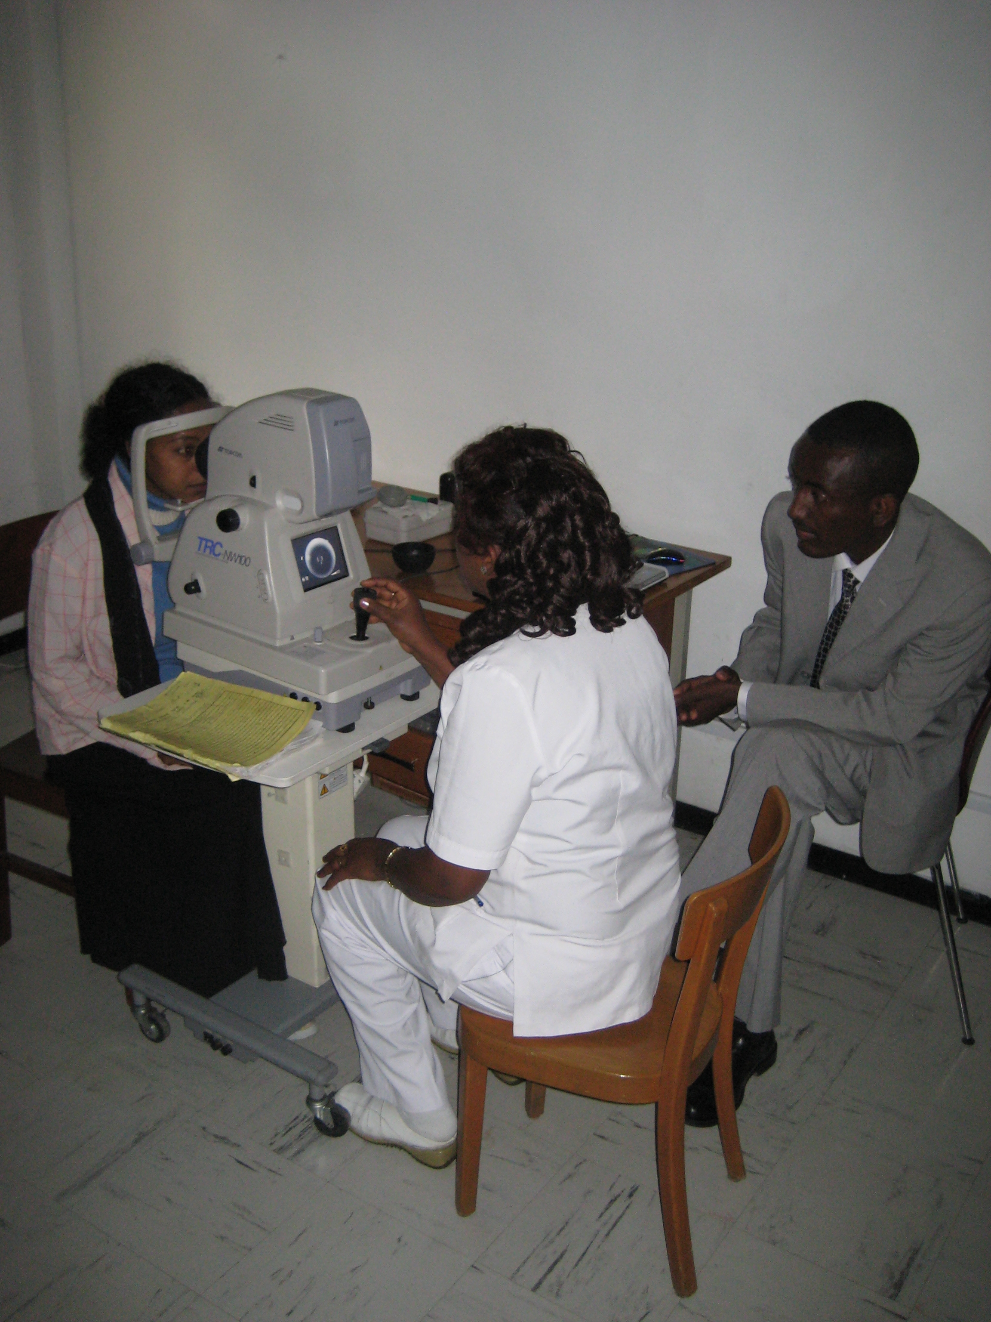

Laurence Quant, Birmingham Heartlands Hospital

BOOK REVIEWS

Diabetic Retinopathy (Oxford Diabetes Library)

Diabetic Retinopathy, edited by Professor Paul Dodson (Oxford Diabetes Library ISBN 978-0-19-954496-7) is a welcome addition to the reference arsenal of the diabetic retinopathy screener. And whilst it’s fair to say that this pocket guide will be of most use to those working in the English national programme, screeners in the other three nations and outside the UK will also find it a succinct and practical resource.

The book is a true pocket guide, small but perfectly formed and well priced at £10 (a proportion of which goes to help establish DRS in Ethiopia). Although much of the content is covered elsewhere, particularly in the NSC’s Workbook 4, the dimensions and additional content make this an essential and constant companion for those tackling the City & Guilds DRS qualification.

Paul Dodson is joined by contributors, from the Birmingham Heartlands DRS programme; each brings expertise to a wide range of chapters covering the many diverse subjects relative to DRS, including a useful and accessibly written chapter on information technology. This straightforward style is a constant throughout the book and where jargon is included the reader is provided with a handy list of symbols, abbreviations and terms necessary to understand the subject.

After Professor Dodson’s introduction, chapters cover the majority of topics dealt with in the City & Guilds qualification; diabetes, anatomy, the screening episode, grading etc., as well as detailed coverage of both medical and ophthalmological treatment of DR, introducing ideas which, although outside the role of the screener, should certainly be of interest.

Different levels of DR are outlined with a separate chapter on background, pre-proliferative and proliferative disease, maculopathy and advanced DR as well as a concise chapter on how to grade. This section, broadly speaking, adheres to NSC’s classifications but also introduces the concept of local protocols within nationally accepted criteria.

Useful chapters include one by Professor Jonathan Gibson covering other ophthalmic lesions of the fundus likely to be seen from day to day on a DRS programme, the basics of programme administration and some “myth busting”, including dilation of patients with glaucoma. There is little here to criticise.

However, a couple of minor points - mainly associated with editing - which include a handful of typos, some repetition and one incorrect illustration. Added to that, a small number of retinal images are reproduced at such a small scale as to be of limited use (unavoidable, if you want to fit the thing in your pocket) and a couple are just not very good examples of the condition they are designed to illustrate. But these are minor and in my opinion Professor Dodson and his team have produced a book that everyone involved in DRS should own. It is small but never “lightweight”, easy to have with you at all times in the working day, concise and provides good clear answers to your own questions, not to mention those that patients will inevitably ask a screener. And (in these cash strapped times) it’s great value for money. Buy a copy now or, better still, get your boss to buy you one (each).

Funds from the sale of this book will go towards buying laser equipment for the LEOPARD programme in Ethiopia.

Bibliographic Details
Paperback: 184 pages published 2008
ISBN 978-0-19-954496-7
Publisher: Oxford University Press
Edited by Paul M. Dodson

Book review by Grant Duncan

A Practical Manual of Diabetic Retinopathy Management

A comprehensive book with high-quality photographic, optical coherence tomography, fluorescein angiograms and oximetry images.

The various classifications of diabetic retinopathy and maculopathy are tabulated including the International and English screening classification, covering all degrees of retinopathy and maculopathy with image examples and case studies together with the possible forms of treatment and contra-indications to treatment in each case.

The surgical techniques involved in vitrectomy and retinal repairs are explained diagrammatically as is the use of VEGF and PKC inhibitors as a medical treatment.

The epidemiology of diabetes world-wide and advances in its management and that of retinopathy are covered, along with risk factors (modifiable and non-modifiable) affecting the progression of diabetic retinopathy. The effect of pregnancy on diabetes and classification of blindness are also covered, again, with good case studies and other ocular complications which are common in diabetes are listed with good image examples (e.g. CRAO, BRAO, CRVO, BRVO, anterior ischaemic neuropathy, asteroid hyalosis, macroaneurysms and emboli). These provide a very useful visual dictionary, as does the section on other conditions which might be confused with diabetic retinopathy, including drusen, AMD, myelinated nerve fibres, sickle cell, radiation and interferon retinopathies.

Although this book is aimed more at ophthalmologists it is a very useful reference and extended reading book with good practice points at the end of each section.

Bibliographic Details
Hardback: 214 pages published 2009
ISBN 978-1-4051-7035-2
Publisher: Wiley-Blackwell
Authors: Peter Scanlon, Charles Wilkinson, Stephen Aldington, David Matthews.

Book review by Jacqueline Mansell

Vision Aid Overseas in Burkina Faso

In November of last year I travelled to Burkina Faso to take part in Vision Aid Overseas direct service clinics in the towns of Kaya and Zinaire. Spending a week in each town nine optometrists and two dispensing assistants screened the sight of approximately four thousand people and dispensed three thousand pairs of donated spectacles. We were also able to refer many people for cataract operations and treatment for other eye diseases. We could not help everyone. Glaucoma is a problem in the region and without treatment leads to severe sight loss. Corneal scarring is also prevalent as a result of injuries and infection.

The Burkinais are friendly and remained good tempered despite having to wait for many hours in the heat in order to see us. As news of our presence spread the number of people waiting to greet us each morning increased illustrating the great need for eye care in the country. The clinics were hard work but the trip was a fantastic experience that I would recommend to anyone.

For further information on Vision Aid Overseas the website is: www.vao.org.uk

Hazel Proudlove, Optometrist - Shropshire Diabetes Eye Screening Programme

The New Qualifications in Diabetic Retinopathy Screening

Hopefully, everyone is now aware that the Certificate in Diabetic Retinopathy Screening has recently been updated. The reason for this was twofold:
firstly, to comply with the migration of all awards to the new Qualifications and Credit Framework and secondly, to allow an update to the content of the award as National Screening evolves.

The process has involved small revisions to the learning outcomes and assignments for each unit and major revisions of the guidance for candidates and learners, and the guidance for assessors, in particular. Hopefully, this will provide greater clarity for all involved. Subject experts from all four nations have collaborated in the development of a suite of awards – possible because of the new structure of the framework. Alongside this the level, (an indication of difficulty) for each unit and for the overall qualifications themselves have been set and credits have been allocated. The experience of candidates taking the old certificate has allowed a fairer judgement of the actual work involved in completing each unit. The credit value of the unit is an indication of the amount of time an average learner would spend in order to obtain the knowledge and skills required. Each 10 hours of learning equals 1 credit. The overall level for the qualifications remains at Level 3, but unit 6 (imaging) has been individually levelled at level 2 and units 7 and 8 at level 4.

The suite of new qualifications contains two Diplomas and three Certificates in Diabetic Retinopathy Screening. The mandatory units to be completed for each qualification are given below together with the credit value:

Level 3 Certificate in Diabetic Retinopathy Screening (Imaging)
Units 1, 2, 3, 4, 5, 6 (35 credits)

Level 3 Certificate in Diabetic Retinopathy Screening (Grading)
Units 1, 2, 3, 7, 8 (33 credits)

Level 3 Certificate in Diabetic Retinopathy Screening (Administration)
Units 1, 2, 9 (21credits)

Level 3 Diploma in Diabetic Retinopathy Screening
Units 1, 2, 3, 4, 5, 6, 7 (44 credits)

Level 3 Diploma in Diabetic Retinopathy Screening
Units 1, 2, 3, 4, 5, 6, 7, 8 (48 credits)

These changes have only been possible because of the structure of the new framework. It is hoped that this will allow much more flexibility for screeners and employers throughout the UK. And at the end of the day it is all about giving patients the confidence that every person involved in the screening process is competent and up to date.

Deborah M Broadbent

2009 Conference Programme

Thursday 1st October

11.30 Registration
12.30 Lunch
13.30 Chairman’s Welcome – Grant Duncan
First Session Chair – Dr Richard Greenwood
13.35 Diabetic Retinopathy Screening in Scotland
Dr Roderick Harvey - Former DRS Clinical Lead (Scotland)
14.00 EQA – Where are we now?
Fionna O’Leary- ENSPDR
EQA – Tales from the frontline
Three Speakers
EQA – Questions from the floor
Your chance to put your questions to an ENSPDR panel
15.30 Tea & Coffee/Trade Exhibitors
Second Session Chair – Grant Duncan
16.30 Challenging cases presenting to a screening programme
Ms Cathy Egan - Moorfields London
16.50 The BARS online forum – live demo
Richard Dewhirst - Suffolk DRS
- Close

Friday 2nd October

First Session Chair – Jacqueline Mansell
9.00 DRS Grading Criteria
Mr Stephen Aldington - NSPDR Cheltenham
9.20 OCT in DRS – A Look to the Future
Mr Martin Harris - Consultant Ophthalmologist Barnet
9.40 Screening in Prisons
Sue Cobbold - Suffolk DRS
10.00 Results of the BARS Survey
Dr Kevin Shotliff Consultant Diabetologist - Chelsea & Westminster Hospital
10.15 Tea & Coffee/Trade Exhibitors
Second Session Chair – Richard Dewhirst
Presentations and open forum on the following topics
11.00 Modernising Scientific Careers
Mr Christopher Mody AOSP Registrar
11.30 The Voluntary Registration Council
Mr Terry Johnson Chairman VRC
12.00 Continuous Professional Development
Grant Duncan Chairman BARS
12.30 The TOPCON Lecture - Introduced by Jacqueline Mansell
Medical management of diabetic retinopathy: any progress?
Professor Paul Dodson -Birmingham Heartlands Hospital & Aston University
13.15 Conference close
Jacqueline Mansell

